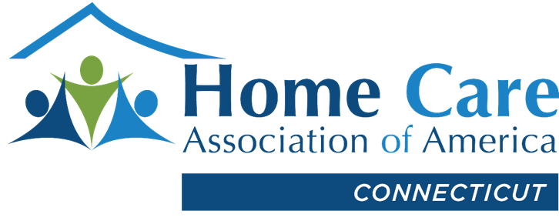

Bills on HCAOA Connecticut’s Legislative Agenda

Several priority bills on HCAOA Connecticut’s legislative and public policy agenda remain on lawmakers’ desks, including the following. Please note that, at this late stage of the legislative session, the status of bills can change rapidly with amendments, committee referrals and passage, so the list can become outdated quickly.

House Bill 5332, An Act Prohibiting Home Care Agency Contracts That Penalize Clients for Directly Hiring Agency Staff. The bill bans nonsolicitation agreements in home care. The Chapter is vigorously opposed to the bill and has issued several legislative alerts to urge members to contact their legislators to oppose it. The bill, which has been approved by the Human Services Committee and has strong bipartisan support, is on the House calendar.

Senate Bill 262, An Act Concerning a Study of Homemaker-Companion Agency Issues. The bill establishes a home care task force. HCAOA Connecticut supports the bill and seeks to participate in the study. The Chapter is urging lawmakers to include nonsolicitation agreements in the study, thereby making its review complete and HB 5332 unnecessary. The Senate adopted an amendment that includes the chairperson of HCAOA Connecticut as a member of the task force, and passed the bill; it is on the House calendar.

House Bill 5227, An Act Establishing the Community Ombudsman Program for Home Care. The bill establishes a community ombudsman program to respond to complaints regarding HCBS. HCAOA Connecticut is not opposed to the bill but urged the legislature, before it adopts the program, to address the significant caregiver shortage and increase Medicaid reimbursement rates for providers participating in the Connecticut medical assistance program. The bill has been approved by the Human Services and Appropriations committees.

Senate Bill 261, An Act Concerning a State Income Tax Deduction for Home Care Costs. The bill provides an income tax deduction of up to $60,000 for certain home care-related expenses. HCAOA Connecticut supports the bill, which was approved by the Aging Committee and referred by the Senate to the Finance Committee.

House Bill 5301, An Act Concerning Workforce Development and Postsecondary Education. The bill requires the Board of Regents for Higher Education to study issues relating to workforce development in the state. HCAOA Connecticut supports the bill and would like the board, as part of the study, to examine the caregiver shortage faced by home care agencies. The Higher Education and Employment Advancement Committee approved the bill, which the House amended to replace the study with other, unrelated provisions.

House Bill 5330, An Act Concerning the Department of Consumer Protection’s Recommendations Regarding Various Revisions to the Consumer Protection Statutes. The bill makes technical and conforming changes to definitions of homemaker-companion agency terms and the ban on noncompete agreements and prohibits HCA owners, agents, corporate officers and employees (other than a client’s immediate family member) from serving as a client’s agent under a power of attorney. The General Law Committee amended and approved the bill, which is on the House calendar.

The regular legislative session adjourns Wed., May 4, 2022.

Here is the status of several other public policy issues HCAOA Connecticut is participating in or monitoring:

Medicaid reimbursement rates. Recently increased Medicaid reimbursement rates, some retroactive to 2021, have finally hit the accounts of home care providers. The new rates provide significant relief to Chapter members who advocated vigorously for increased rates in the face of rising costs. Last month, Connecticut Department of Social Services officials met with Chapter leaders to discuss the new rates and their plans to make several new rates permanent and ongoing past July 1, 2022. Additionally, the officials welcomed an appointment of HCAOA Connecticut DSS Medicaid committee chair Marlene Chickerella of B&M Homemaking in West Haven to serve on an internal ad hoc committee comprised of home care providers and others who discuss rates and policies related to HCBS. Also, HCAOA Connecticut invited officials to participate in a program next month concerning the Medicaid program and reimbursement for providers.

Unemployment insurance trust fund. Connecticut employers, including HCAs, face significant costs to repay federal loans for unemployment insurance. The state borrowed $888 million from the federal government to cover the historic unemployment benefit claims caused by pandemic-driven government shutdowns and restrictions. As employer taxes fund the unemployment trust fund, businesses face tax hikes through Nov. 2026 – based on Department of Labor estimates – to pay off those federal loans. According to CBIA, Connecticut employers are responsible for $763 million in federal loan repayments, representing $467 per employee. To date, $425 million in loan repayments have been made, with businesses covering $300 million. Absent additional help, employers are responsible for the remaining $463 million loan balance.

Homemaker-Companion Agencies Advertising Guidelines: The Connecticut Department of Consumer Protection has adopted advertising guidelines, which, among other things, expressly prohibit a home care agency from advertising any type of memory, Alzheimer’s or dementia care. The document of frequently asked questions indicates that HCAs and caregivers can offer help with dressing, showering and toileting and remind clients to take their medication.

April 24, 2022

