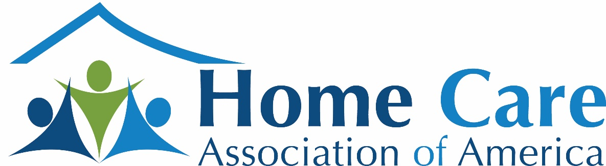

2023 Board of Directors Nominees

- Mike Coccaro
- Dan Drennen
- Margaret Haynes
- Brett Ringold
- Greg Solometo
- Milton Schopper
- Doug Wilbur
- Sara Wilson

Mike Coccaro
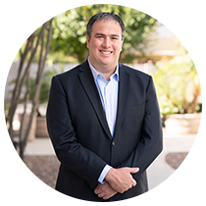
Bio
Please see my LinkedIN Profile: https://www.linkedin.com/in/michael-coccaro-2953785/
I am the representative for SYNERGY HomeCare, a Corporate Member of HCAOA. We have over 430 units offering home care services in 40 states. I have been the General Counsel of SYNERGY HomeCare for almost 8 years and have served other roles in the organization, including in Operations. I have worked with HCAOA in the past including the AB 2455 litigation. I was a member of the Management Team when SYNERGY HomeCare partnered with our private equity sponsor and helped develop and participate in the growth strategy to deliver results.
Relevant other memberships include: American Bar Association Forum on Franchising and Corporate Counsel Division. Several publications in franchise law including The Franchise Lawyer and The Franchise Law Journal

Questions
What specific expertise would you bring to the HCAOA Board of Directors?
While I have been General Counsel for SYNERGY HomeCare since December 2014, the company was a client of mine when I was in private practice dating back to 2009. I have been able to watch the Company grow and then, once I became General Counsel, to help it grow to new heights. Aside from my specialty area of training (franchise law), I have developed a deep understanding regarding the various laws and regulations that touch on home care. I witnessed and participated in our industry going through significant changes including (1) changes in wage and hour issues, (2) a rise in paid sick leave time and local minimum wage laws, (3) a rise in state licensure, (4) the inclusion of home care and its rise in Medicare Advantage Plans, (5) several iterations of joint employment law, and (6) the rise in the importance of data privacy laws. In addition, I serve on the steering committee to help draft the COVID-19 Recommended Protocols with Littler and now Polsinelli. I have also helped key industry vendors develop and customize products to serve our industry and learned what makes a home care agency successful over time.

Why do you want to serve on the Board of Directors?
SYNERGY HomeCare is eager to interact with our peers and partners and learn and share information. I believe HCAOA is in the best position to advocate on behalf of this industry and, although I have worked with HCAOA in the past to accomplish these goals, I’d like the opportunity to continue in a more formal role.

Dan Drennen
*See Attached Resume
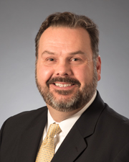

Questions
What specific expertise would you bring to the HCAOA Board of Directors?

As SVP of Brand Administration of Visiting Angels, I bring a fresh perspective of how the home care and franchising industries can work together to help seniors receive quality care that leads to positive client outcomes. I have expertise in brand and risk management, having worked at Visiting Angels for 13 years and helped develop the company as an international brand. My experience in regulatory and legal affairs in home care and franchising will add knowledge and wisdom in both of these realms to the board.

Why do you want to serve on the Board of Directors?

I desire to serve on the HCAOA Board of Directors as a Brand Ambassador for Visiting Angels and deepen our mutually beneficial relationship. We want to be a franchisor who is engaged with the industry and connected to other key players. Furthermore, attaching ourselves to the mission of the HCAOA allows us to have greater impact, not only as a franchisor, but all of us, coming together to make a difference in the industry that we love and care about.

Margaret Haynes
*See Attached Resume

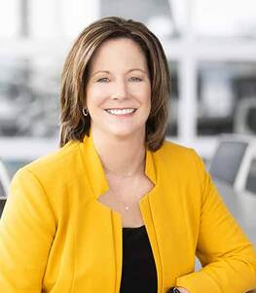
Questions
What specific expertise would you bring to the HCAOA Board of Directors?

Having joined Right at Home in January 2011, I have spent the last 12 years immersed in the home care industry. From both a Franchisor perspective and a consumer of home care services, I bring a broad perspective and an incredible passion for the impact homecare can have on so many lives. I also bring an untiring drive to look at the industry from multiple perspectives, recognizing the need to holistically think about our industry.
Specific expertise includes strong business acumen and proven leadership, Certified Senior Advisor designation, understanding of the industry and associated headwinds and tailwinds, and collaborative approach to driving success.

Why do you want to serve on the Board of Directors?

I would be honored to serve on the HCAOA Board of Directors, as I believe in the Association’s mission and the value that comes from a strong industry-wide focus.
As a Board Member, I would be a dedicated and active member ready to help support the industry and continue to build and strengthen our collective voice. I’m a firm believer that the various headwinds we face as an industry (e.g. caregiver shortage, need for improved quality standards, expanded advocacy, and seat at the healthcare table), are not obstacles, but rather opportunities.
I also believe it’s important - perhaps now more than ever - for our industry to be united. Homecare plays an extremely important role in the healthcare ecosystem and needs to continue to actively engage and educate across many groups/ constituents.
At an important inflection point for the industry, I will bring an untiring passion for helping all members of HCAOA (regardless of ownership/brand structure) to build sustainable, profitable businesses that allow our industry to continue to impact so many lives in a very meaningful way.

Brett Ringold
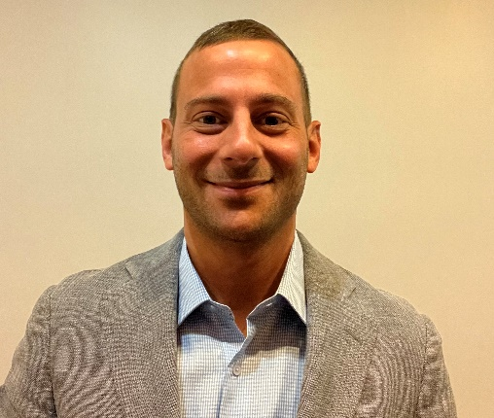
Bio
Brett Ringold, Vice President of A Long Term Companion (ALTC), has over a decade of experience as a home care agency owner and operator.

Brett is a well-respected expert on agency operations, and he has been a featured speaker in conferences, webinars and podcasts with Home Care Association of America, Pennsylvania Homecare Association, and Home Care Pulse. His presentations have covered a wide range of topics, including using data to reduce caregiver turnover, how to master scheduling, and the state of home care in Pennsylvania.

Since its founding in 2010, Brett has led his agency through the process of becoming a Medicaid waiver provider, obtaining licensure and operating in multiple states, earning home care accreditation from The Joint Commission, and growing a workforce of just 3 to over 150 caregivers and administrators.
His agency has achieved Home Care Pulse’s Best of Home Care Employer of Choice and Provider of Choice awards for the past three years, in addition to the Leader in Excellence award in 2021. Today, almost half of ALTC’s caregivers have at least 3 years of tenure, and nearly one out of four caregivers have worked with ALTC for at least 5 years.

Having been a home care patient as a young adult, Brett has a unique perspective as an agency owner. Since he was a teenager, Brett has understood how vital home care is to the healthcare industry as a whole. Now, after running his own agency for over a decade, he has spent the last few years sharing best practices and strategies on various platforms, helping other agencies to improve their operations.
Brett believes that we are at a tipping point as an industry, and that the pandemic has shone an overdue spotlight on the importance of home care. If elected, he promises to bring passion and a tireless work effort to be a voice for agency leaders across the nation, and to do everything within my his to advance our industry.

Brett is a member of the Pennsylvania Home Care Association’s Board of Directors. He graduated from Temple University with degrees in Finance and International Business.

Questions
What specific expertise would you bring to the HCAOA Board of Directors?
I feel as though I have a unique perspective as a home care agency owner, having had my first experience with home care as an 18-year-old patient following a hospitalization for a Crohn's disease flare-up. The care that I received was not overwhelmingly positive, and this episode ultimately led my mother, Michele, to found A Long Term Companion.
When I joined my mother in 2010, our agency was working out of a home office and had just two clients and three caregivers. Today, we are licensed in multiple states, serve hundreds of families each year, and have a team of over 140 amazing professional caregivers.
Under my stewardship, our agency earned The Joint Commission's Gold Seal of Approval ® for Home Care Accreditation in 2019, achieved Home Care Pulse's Best of Home Care Employer of Choice and Provider of Choice awards for the past three years, and were also awarded the prestigious Leader in Excellence award by Home Care Pulse in 2021.
For the past 12-plus years, my primary focus has been to establish A Long Term Companion as a leading home care agency in the Delaware Valley. We have earned a great reputation in the region by providing the highest level of home care services to our clients, and being the best possible employer to our caregivers.
I've learned countless lessons along the way and have had the honor of sharing many of these insights and principles with other agency operators. I've been a featured speaker and panelist in conferences, webinars and podcasts with Home Care Association of America, Pennsylvania Homecare Association, and Home Care Pulse. These presentations were all specific to home care operations, with topics that include using data to reduce caregiver turnover, how to master scheduling, and the state of home care in Pennsylvania.
What I am most proud of in my career as a home care agency owner is the extremely strong culture that we have established. Even as a growing agency, nearly half of our caregivers have been part of the A Long Term Companion family for at least 3 years, and roughly 25% of our caregivers have worked with us for at least 5 years.

Why do you want to serve on the Board of Directors?
I've been interested in serving on the HCAOA Board of Directors for a few years now, but that enthusiasm has grown one hundred-fold after attending this year's Annual Leadership Conference. In Orlando, I had the opportunity to meet with so many agency owners from across the country, and I was truly blown away by their passion and desire to make a positive impact in their local communities.
Our agency became a member of the Home Care Association of America in August of 2019. Initially, I was passively involved as a member of HCAOA, however over the past few years, I have become more active. I was selected to present at the 2020 HCAOA Annual Leadership Conference, which was a great honor for me. My session was titled Keeping our Caregivers at the Core, and it focused on the principle that as operators, we are really serving two clients every day. Those who pay for our services, and our caregivers. Last year, I presented a session at the 2021 HCAOA Learning Lab Series. My session was titled Master Scheduling: How to Schedule for I 00 Clients with One Scheduler Without Breaking a Sweat. Several agency operators reached out to me following this presentation, and I've worked with them to help improve their respective agencies' scheduling processes.
I've understood just how vital the work that we do as agency operators is since I was a teenager, being a former patient of a local home care agency. Now, having been an agency owner for over a decade, I've volunteered a lot of time to help other agency owners improve their operations, by sharing best practices and strategies on various platforms, ranging from conferences and webinars to podcasts and case studies.
I believe that our industry is at a tipping point, as the pandemic has shone a spotlight on the importance of home care. Earlier this year, I was asked to fill a newly vacated seat on Pennsylvania Home Care Association's Board. It would be an honor to be elected by my peers as a member of the HCAOA Board of Directors. If elected, I promise to bring passion and a tireless work effort to be a voice for agency leaders across the nation, and to do everything within my power to advance our industry.

Greg Solometo
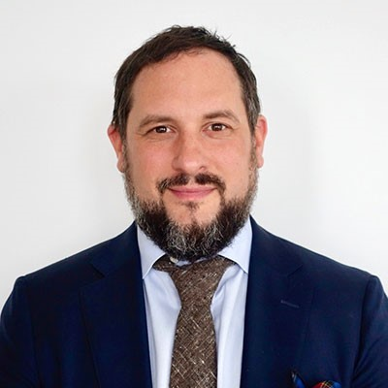
Bio
Gregory Solometo co-founded Alliance Homecare in 2006 after caring for his grandmother with Alzheimer’s. He actively served as the Chief Executive Officer where he has been the lead visionary behind the company’s short and long-term strategic initiatives. Alliance Homecare is known in the industry as the first innovator of Concierge homecare and private duty nursing. The company’s main geographic coverage is NYC and the surrounding suburbs. Alliance operates a unique model of hybrid Care Management, Homecare and Nursing that represents best in class in the private duty space. Mr Solometo has recently hired Nancy Gillette, an experienced industry growth leader, to take over the day to day running of the business as CEO. He will support her in expanding their model to other markets around the country. Nancy has recently launched a new ultra high end nursing model called Allia which will operate side by side Alliance providing more distinct care options in the private duty market.
Gregory founded the company with two childhood nurse friends after he took care of his grandmother for five years when she was suffering from Alzheimer’s. Gregory’s firsthand experience of searching for caregivers showed him that there were limited resources that met his high level of standards of client care and customer satisfaction. Based on that, they created ‘The Grandma Rule™’ hiring philosophy. Since that time, Gregory has been committed to providing all clients with an elite and highly qualified team of healthcare professionals and partners that exceed industry standards.
Prior to starting Alliance Homecare, Gregory worked for 15 years in the financial services industry. For the final 5 years of his finance career, he worked as a Lean Process Engineer at Deutsche Bank where he provided strategic consulting services to various divisions of the Investment Bank and it’s operations in the US, Europe and Asia.
Gregory graduated from Emory University in 1995. He recently received a Certificate from Stanford Business School in Strategy and Innovation. Gregory is currently writing a book on his experience and has been a speaker at various industry conferences and podcasts over the past several years.

Questions

What specific expertise would you bring to the HCAOA Board of Directors?
I’d be bringing 20 years of both personal and professional experience in the caregiving world. As mentioned in my bio, I undertook direct care for my grandmother at the age of 30 and was her primary caregiver for 5 years. During this time, I was the sole family caregiver and received an education in the aging at home process. Because of this, I deeply understood the challenges, frustrations and dynamics involved in the caregiving journey. Most people in the country receiving care have not done so in the past and require expertise, advice, and guidance from known professionals to navigate that path and create a safe environment. This ecosystem involves more than just trusted caregivers. I realized that I not only had a passion for caring for my grandmother but also had the opportunity to create an industry leading platform that would mimic and improve upon the care I delivered to my grandmother for others. My time as a Lean engineer taught me many things but most important was the Japanese concept of ‘Kaizen’ which roughly translates to continuous improvement. There is no perfect scenario in caregiving or aging in place but there is always room for improvement. Set the bar high, and then keep raising it on yourself.
My goal has always been not only to create a respected service brand but to also influence the improvement of other providers in geographic markets across the country and globe. If I were selected to join the HCAOA Board of Directors, I would be able to help collaborate with a much wider set of influencers not only within the home health arena but across the Healthcare continuum. I would also like to have an impact on the policies that govern and protect our aging population and to help thought generate and collaborate partnerships to that end. There is nothing I would like more than to be helpful and serve this population.
I would also like to help in creating a NYS Governing Body. One does not exist yet. I have spoken briefly with Vicki Hoak in this regard.

Why do you want to serve on the Board of Directors?
I think my above answer covers this question. I believe that to find meaning in life is to understand your purpose. I strongly believe that my purpose is to help improve the way we care for our elderly and for those populations that are vulnerable. Growing up in a time of turmoil, I was taken in by my grandparents and given a life of love, education and generosity. I was fortunate to be able to return that favor and pay that forward to care for them when they needed me. I created a best of breed operation which now runs without my direct influence day to day. I am ready to take on the next level of responsibility which would be to serve the HCAOA and it’s constituents to turn my scope beyond the focus of my company and into the industry to help others in it succeed. The country does not really comprehend the challenges it’s about to face over the next 15-20 years as the millions of boomers comes of age. I also believe that we will largely be living well beyond 100 years in the near future which means that our industry is going to take on more prominence in helping solve some of those problems. I’d be honored to take part in that process.

Milton Schopper
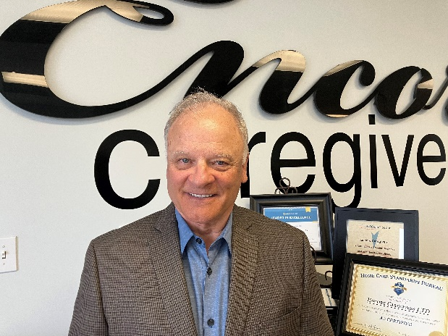

Bio
Milton D. Schopper is a business leader with more than 40 years of management experience. A graduate of Arizona State University with a BSE in Chemical Engineering, he began his career in the oil industry as a District Engineer for BJ-Hughes Services.
In five short years, he founded his own company, TRU-TAG Systems, Inc. and in another five years, the company had service crews staffing worksites in Bakersfield, California; Oklahoma City, Oklahoma; as well as Midland, Dallas, Houston and Longview, Texas. The supply of low-level radioactive tracer elements being key to TRU-TAG Systems’ business, he then founded ISO-TECH Laboratory, a tracer production facility, and served as manager.
In December of 1994, Mr. Schopper and key staff members began the development of a fiber optic-based fluid detection and control system for above-ground oil storage tanks. He received a patent for the device in September, 1995. He oversaw the sale of the technology to a Houston-based service company and served as president of the new spin-off company, HMT Sentry Systems, Inc.
In 1997, Mr. Schopper once again followed his entrepreneurial bent and launched his own consulting firm, MDS Communications, Inc. – The Alternative Board. This endeavor served to help larger small to medium sized firms improve business performance. This effort was innovative, as business CEOs in non-competing businesses served as each other’s board of directors – with Mr. Schopper as facilitator.
In early 2015, Mr. Schopper was presented with a solid business opportunity by a client: purchase his large, non-medical in-home care business in Houston. Since Mr. Schopper had been advising this client in in-home care business operations since 1997, he had a clear picture of the industry, the challenges and the many satisfying rewards. He presented the opportunity to his wife, Marilou, and in 2015, they launched whole heartedly into what they both agree is the most significant effort they have ever undertaken in their careers: helping seniors and their families find peace of mind.
Currently, Encore Caregivers serves families throughout the Houston Metro Area and is one of Houston’s largest in-home care agencies -- with a rock-solid reputation.
Milton Schopper and his wife, Marilou, make their home in Spring. They have three sons and four precious grandchildren.

Questions

What specific expertise would you bring to the HCAOA Board of Directors?
I would bring 40+ years of targeted business acumen to the Board of Directors. Through my 18+ years of consulting experience, I have been exposed to a cross-section of U.S. industries – the challenges, the knee-jerk responses, the measured strategies. I have seen CEOs at their best and at their worst and have learned to navigate the many different personalities that make up the business world.
My absorption with ensuring the continued success of Encore Caregivers, since 1997, but especially since 2015, has precluded me from participating in the high level of community involvement that I am used to and that I enjoy. I very much look forward to being able to contribute to the HCAOA board and the organization’s members in a significant way.

Why do you want to serve on the Board of Directors?
Early in 2016, in doing research for the best positioning for Encore Caregivers, I discovered HCAOA. Its core values matched the core values of this agency. I knew that we needed to align ourselves with this national organization. We did so immediately and joined as members then. That 2016 decision was key to providing the best kind of care for our clients and for continuing to grow this agency.
Through a board position, I would strive to serve as a voice to level the playing field for independent agencies throughout the U.S. because of my unique perspective as CEO of Encore Caregivers. Daily, I see non-family-member-private caregivers entering the marketplace to take care of loved ones. They do not always charge overtime and because of this have an appeal to families. However, so often, they are not trained, insured, licensed, and not bonded. These caregivers don’t enjoy the recourse of workman’s compensation, disability and unemployment benefits. They are without protection. In addition, the danger to loved ones is real – the financial exposure of families is great. I would like to do what I could to mitigate that situation.
I know how beneficial membership in HCAOA has been to our agency. It is a real resource for families as well as a marketing tool for Encore Caregivers. When someone calls and needs help, and they live well outside of the Houston Metro Area or even out of state, we use the HCAOA Website to steer them to HCAOA members. Our standard advice is, “We are members of the Home Care Association of America. We have always found members of the HCAOA to have higher standards of care than non-members. Please let me send you a list of members near your loved one.” They are encouraged and very grateful as we deliver multiple agency names within 15 miles. We wish them luck and God’s blessings. We feel that we have intervened and offered a significant first step in solving a real problem for this family.
Has the message of HCAOA’s benefits permeated the senior in-home care industry? Can we use targeted messaging to drive membership? When you are hammer, everything is a nail (as they say), but communications is the key business tool and always has been, as I see it. I am committed to see enhanced communications serving as a driver for this organization. It would be so beneficial to continue to build services of this organization to benefit the industry and ultimately the families in need. As our efforts to establish a Texas State Chapter gain traction, I would take real pride in seeing the fruits of our recent labors.

Doug Wilbur
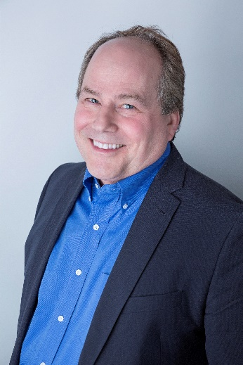
Bio
Is the CEO and Founder of Cherished Companions Home Care in Chagrin Falls, Ohio serving the Cleveland area. Doug started Cherished Companions to enable people to thrive in their homes through all stages of life. Doug grew up in a family of physicians (four generations) driving a lifelong passion for patient care. Doug received his Bachelor of Science degree from Bowling Green State University in Biology.
He has held numerous positions in his work career. He was the owner and president of The Fisher Sales Agency, a manufacturer’s rep organization. He then was hired by Procter and Gamble in their health care division where he spent 22 years in various roles. He worked in sales, training, consulting, marketing, and management. Doug worked on numerous projects and advisory boards there. He received numerous awards at P&G including multiple Pacesetter awards and even achieved P&G’s top award for significant achievement, The Recognition Share Award, twice. A pivotal role in his career was at P&G’s HCI (The Healthcare Consumer Institute). HCI was founded as a research and consulting arm of Procter & Gamble dedicated to pioneering unique research methodologies used to understand patient behaviors and improve patient outcomes. In that role, he came to uniquely understand gaps in the health care system. One of those gaps was the significant care needs of those with chronic conditions, and the effects of aging. This understanding drove him to set out to create a model of care for home care based on that research.
Doug retired from P&G to found Cherished Companions in 2009. Cherished Companions is one of the larger agencies in Ohio, is a multiple recipient of the Home Care Pulse Leader in Excellence Award and has over 250 active employees. Doug has been Vice Chairman of the Ohio Chapter of the Home Care Association of America since the chapter was started. Ohio has recently legislated and implement licensure for Home Care. He has been a member of numerous local professional groups such as ASNE, PASS, BNI and the Chamber of Commerce. Cherished Companions has been recognized by Fortune Magazine as 3rd and 5th in the nation for best places to work. He has spoken at the HCAOA Annual Conference on ways to gain and retain excellent employees.

Questions

What specific expertise would you bring to the HCAOA Board of Directors?
I have spent over 35 years in health care professionally with a wealth of experiences and expertise. I have specific expertise in sales, marketing, patient care, the physician perspective, health care models, the patient/client experience, in health care science, technology, chronic illnesses, entrepreneurship, and training. My experience with starting and running a larger independent agency successfully helps to provide that perspective on a diverse board. I also have advocated at the state level in Ohio and have gained experience with the process and pitfalls of licensure.

Why do you want to serve on the Board of Directors?
I think my knowledge and diverse experiences will help to add to the HCAOA Board. I believe that we are navigating new waters and having a diversity of skill and knowledge sets on the board will help the HCAOA to continue to be successful. I see this as an act of service to help shape the direction of the home care field and advocate for our industry. Home Care is a newer sector and the direction we set at the HCAOA will have an impact on health care for years to come. My desire is to see that we create standards and forge practices that will create models that will benefit those most in need for our services.

Sara Wilson
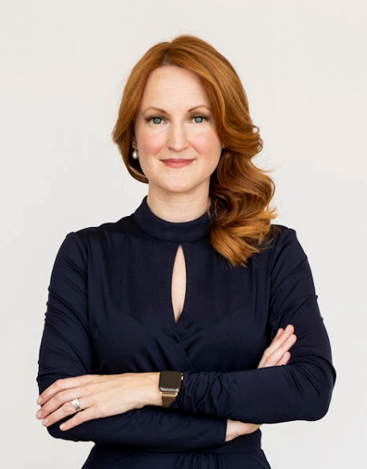

Bio
Sara Wilson has worked in home care for 20 years and has served the last 8 years as CEO of Home Assist Health (HAH), a Phoenix-based non-profit that offers personalized home- and community-based services to seniors and individuals with disabilities. HAH offers a variety of services including personal care assistance, companionship, housekeeping, respite care, habilitation, enhanced care transitions and chronic disease management. A passionate advocate for individuals with complex health needs, innovation has come naturally for Sara. She has spent two decades responding to the changing needs of the folks she serves with creative solutions. Her continued efforts have helped Home Assist Health become one of the most innovative agencies in the Southwest. Through her leadership the organization has become a bridge of compassionate equality for diverse populations through valued partners including Valleywise Health System, Health Current, Mercy Care Long Term Care, United Health Care, Banner University Health Plans, and The Department of Economic Security – Division of Developmental Disabilities. Sara and her team are the frequent recipients of numerous industry and business accolades. Her leadership is also reflected in the national and local boards she sits on including the Partnership for Medicaid Home Based Care, Arizona Home Care Association of America, and the Mayo Community Advisory Board. A graduate of Arizona State University Sara earned her bachelor’s degree in Interpersonal and Organizational Communication and her master’s in Business.

Questions

What specific expertise would you bring to the HCAOA Board of Directors?
I would bring more than 20 years of experience and expertise as a home care operator, advocate, and leader for modern home care. I have a strategic leadership style that is powered by people first and proven by data. My program experience includes senior care, physical and developmental disabilities, and interventions for SDOH and self-health management for highrisk populations. My passion and drive began while working for three years with nationally renowned selfadvocates, advocates and researchers on disability and aging. My work has focused on modernizing the role of home care to meet the current and future health needs of the community. In addition to start up work, I have established new programs, and have managed long-standing programs through the good and hard times. In my current position as CEO to Home Assist Health we run one of the earliest home care companies in the state of Arizona. In 2018, we successfully launched a first of its kind partnership with our state hospital system providing home-based interventions to reduce emergency room visits and hospitalizations. In 2020 we became the Hospital’s COVID-19 Surge partner accepting patients being discharged home as COVID-19 recovered, providing enhanced transition support services. We also serve their clinic patients by helping to address Social Determinants of Health and improve self-health management skills. In some cases, patients referred will enter our long-term care program for ongoing care. I have been leading advocacy efforts with our state Medicaid authority to fund this work through our Medicaid Programs using CPT 98960 as Community Health Work (CHW) services. As of 10/14/22 the state reported they are looking to use 98960 for CHW services and home care providers can be eligible to register as a provider. As a home care advocate, I have met with local legislators including those in key positions including the Senate President, Appropriations committee chair, and the Majority and Minority leaders. In 2019, I was invited to present to the State Senate’s Health and Human Services Committee on the value of home care. I have also participated in Hill meetings as part of the Home Care Association of America and The Partnership for Medicaid Home Based Care.

Why do you want to serve on the Board of Directors?
There has been increasing mention of our country and our industry being at an inflection point. According to Rita McGrath, author of How to Spot Inflection Points in Business Before they Happen, identifies four phases of inflection: Hype, Dismissive, Emergent, and Mature. As I see it, our country’s health care system and our home care industry are in the emergent stage of inflection where healthcare and home-based services are converging. I want to serve on the board of directors because I am motivated to help leverage this point of inflection to elevate and expand the role of home care through the Maturity Stage while keeping home care providers as the expert of home-based care.

